Staffordshire County SOWA Discovery Course - Application Form

Details of Course
Course Title: Scouts of the World Award (SOWA) Discovery

Course Dates: 13th May & 3rd June 2017

Time: 9.30am – 5.00pm (both days)

Venue: Alsager Scout HQ

Scouting Details
District (Network):

County:

Membership number:

Additional and/or Dietary Needs
I wish to apply for the above Course and have no objection to personal data relating to my membership of The Scout Association being held on computer.

Signature of Applicant (or typed name):

_______________________________

Date:
_______________________________

For administrator’s use:
Date Application received:

Date acknowledged:

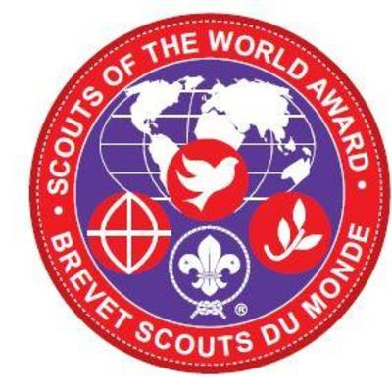

Personal Details
Surname: Mr/Mrs/Miss/Ms

Forenames:

(Please underline the name by which you are known)
Address:

Post Code:

Phone number:
(Mobile preferred)
Email:

Date of Birth:

Emergency Contact name:
Emergency Contact phone no:
ALL boxes should be completed and form signed by the applicant.

This form should be sent to:
Staffordshire County Scouts
Unit 3 – Uttoxeter Business Centre
Town Meadows Way
UTTOXETER
ST14 8AZ

COURSE COST (£25) MUST BE SENT WITH THIS COURSE APPLICATION FORM.

Cheques to be made payable to
“Staffordshire County Scout Council”

For any payment or other booking queries, please contact:

admin@staffordshirescouts.org.uk

01889 567018 (10am-4pm Mon-Fri)

