Volunteer Vacancy Pack

District Commissioner

Kibblestone Scout District

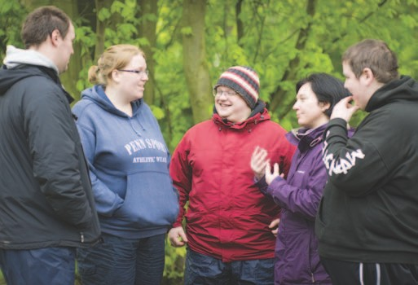
Who we are

Every year we help 400,000 young people in the UK enjoy new adventures; to experience the outdoors, interact with others, gain confidence and have the opportunity to reach their full potential. And it’s not just young people who can get in on the action. Working alongside our youth members are thousands of adult volunteers, with a huge variety of roles and opportunities available.

To find out more go to www.scouts.org.uk

Volunteering

Volunteering for us is easy, fun and offers many opportunities for gaining externally- recognised qualifications. Why not strengthen your CV while making a real impact on the lives of young people?

How much time you give is up to you, and you don’t need any previous experience. We have a huge variety of roles to suit everyone, and whatever you choose, we’ll make sure you’re properly trained and supported.

Who are you?

We’re looking for someone with management skills who can provide leadership, motivation and inspiration. As District Commissioner you will support and guide adults through their Scouting journey and ensure that young people can access the best possible Scouting.

Scouting in your area
The line management structure in your area will be as follows:

District Commissioner - supporting the local Kibblestone District (Primarily Kibblestone International Scout Camp)

County Commissioner - Supporting a collection of districts in Staffordshire

Regional Commissioner - Supporting the County Commissioners

These people have responsibility for a number of things – developing Scouting, ensuring safety, and that the policies of The Scout Association are upheld. They also manage and support adult volunteers in Scouting. For any adult in Scouting, their ‘Line Manager’ will always be a regular point of call for support.

Thank you for your interest in volunteering with the Scout Association. Contained in this pack is a role description and person specification for the role of District Commissioner. If you think you know just the right person for this role, or are interested in the role yourself, please complete the nomination form at the rear of the document and send it to the person named. If you would like more information or an informal chat about the role, please contact: Staffordshire County Scouts 01889 567018

Outline of role: To manage and develop Kibblestone Scout District. To ensure that Kibblestone International Scout camp runs efficiently and that it is developed in accordance with the rules and policies of The Scout Association (Kibblestone is a special circumstance district which consists solely of Kibblestone International Scout camp and its associated properties).

Person Specification
Knowledge and experience Essential / Desirable
Ability to manage adults effectively Essential
Ability to plan strategically for the development of the business Essential
Understanding of financial and employment procedures in a business setting Essential
Experience of managing Health and safety Desirable
Understanding of the challenges of working in the voluntary sector Desirable
Experience of working with young people and/or community groups Desirable
Experience of working in the Scout or Guide movement or other youth
organisation as an adult Desirable

Skills Essential / Desirable
Excellent written and oral communication skills Essential
Provide advice and guidance effectively to others Essential
Provide inspirational leadership for the District Essential
Provide strategic direction for the District Essential
Motivate adults volunteering in the District Essential
Build, maintain and facilitate effective working relationships with a Essential
wide range of people
Enable others to identify issues, clarify objectives, develop attainable Essential
objectives and gain the necessary skills and confidence to work as an
effective team
Ability to negotiate compromises Essential
Plan, manage and monitor own tasks and time Essential
Construct and implement long term plans that improve and expand the Essential
Scouting offered to those using Kibblestone Scout Campsite and identify
any training, resources and other needs required to undertake this work
Use basic computer software Essential

Personal Qualities Essential / Desirable
An understanding of the needs of adult volunteers Essential
Flexible approach Essential
Self - motivated Essential
Able to work as part of a team and promote good teamwork Essential
Resourceful, energetic and enthusiastic about the job Essential
Acceptance of fundamentals of the Scout movement Essential
Notes: 1. Please copy this blank form if making more than one nomination. 2. Self-nominations are welcome. 3. All nominations are dealt with in the strictest confidence.
Nomination Form District Commissioner

If you think you know just the right person for this role, or are interested in the role yourself, please complete the nomination form below.

Name of nominee

Address

Telephone
Daytime | Evening

Email

Membership number
(if appropriate and if known)

Please explain why this person is suitable for this role, including relevant professional and voluntary experience from inside or outside Scouting (refer to role description).

Please describe the relevant skills that this person has for the role (refer to role description).

Please outline why you felt motivated to complete the nomination/self-nomination.

Nominated by

Contact details (name, address, phone/mobile number, email)

Signature Date

This form should be returned to:
Staffordshire County Scouts, Unit 3 Uttoxeter Business Centre, Town Meadows, Uttoxeter, ST14 8AZ
or email to: admin@staffordshirescouts.org.uk
The closing date for receipt of applications is: 25th January 2016

