County Youth Commissioner
Staffordshire County Scouts

Vacancy Pack and Role Description

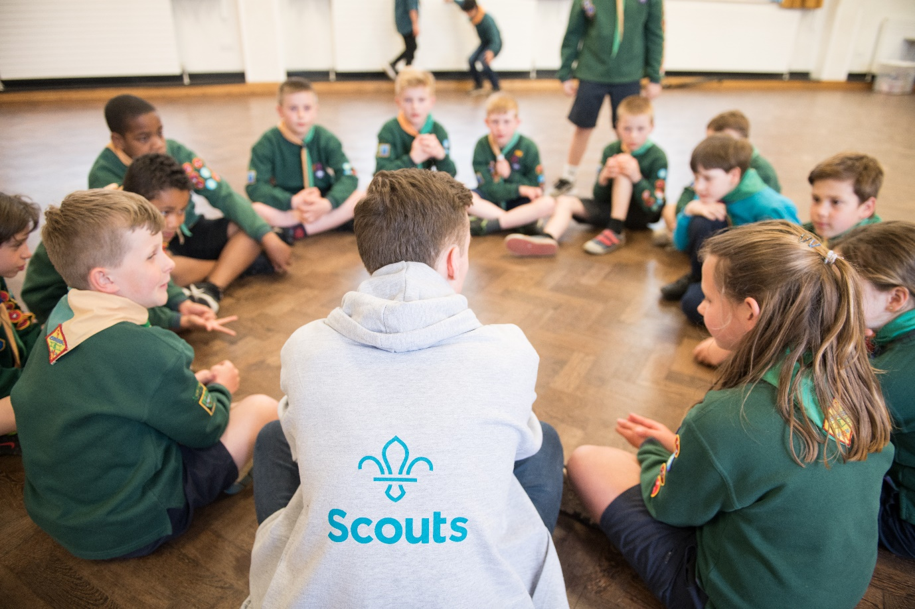

Staffordshire County

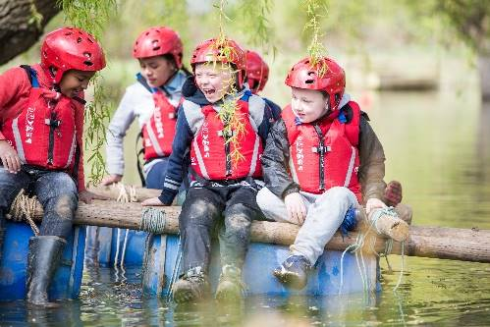
About Us

Staffordshire Scout County is a thriving County with 12 Districts and over 7,900 young members and 2600 adults.

Overview of Youth Shaped

At Scouts, we provide young people with the opportunities to develop Skills for Life – including confidence to speak up, feeling empowered to make a difference and being ready to take the lead.

That’s what being youth shaped is all about. Our programmes and decisions are shaped by young people, working in partnership with volunteers.

The difference you’ll make to young people.

Youth Commissioners help young people to make their voices heard and improve scouts for the better. You’ll be working to help more young people get the opportunity to speak up and take the lead – skills and experiences that let them up for the future. And in the process, you’ll get to learn plenty of new skills yourself too.

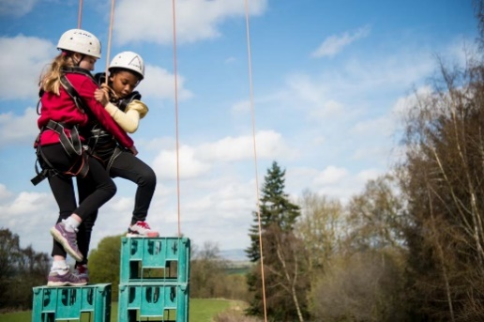
Supporting Adventure

Staffordshire County are responsible for supporting the delivery of active and adventurous programmes for all sections.

In all sections the focus is on the delivery of a balanced yet exciting programme with a focus on developing skills for life through outdoor activities and adventure.

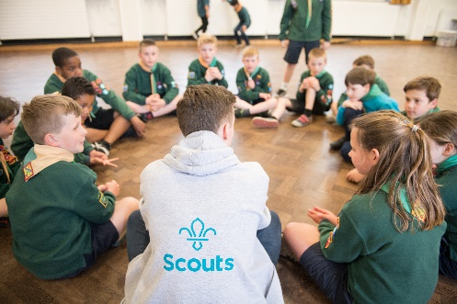
Youth Focus

Through our Youth Shaped initiative, we reflect the fact that Scouting is a youth Organisation led by young people and supported by adults. Young people are at the heart of our decision making with respect to programme, events and competitions and influence our development strategies, local objectives, priorities, and governance.

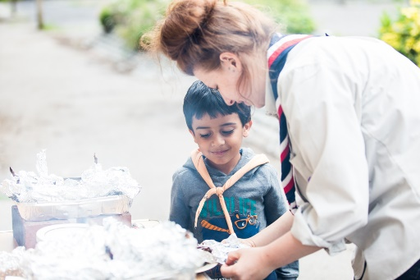
Development

Scouting is a growing movement and Staffordshire County has potential for good growth of both youth Members and Adult volunteers. Supporting growth and development is important to ensure that we can accommodate the growing number of young people who wish to join the world’s largest and most successful youth movement. This means recruiting more adults and opening new provision to meet demand.

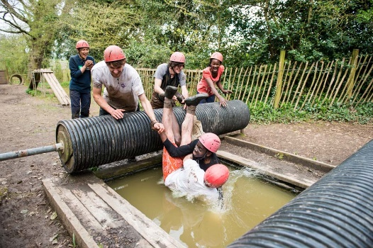
Find out more

To find out more about us please visit our website at

www.staffordshirescouts.org.uk

Thank you for considering the role of County Youth Commissioner or nominating someone you think would be good for the role, it will make a huge difference to Scouting in Staffordshire.

ROLE
DESCRIPTION
This vacancy is for the County Youth Commissioner of Staffordshire County Scouts, At the 2023 membership census we had over 7900 youth members between the ages of 4 and 25 involved in our Squirrel, Beaver, Cub, Scout, Explorer, Network and Young Leader sections. We have over 2600 adult volunteers, who undertake roles including working directly with young people, adults who manage and support other adults, adults who are experts in programme and activity areas and adults who support elements of the programme along with adults who manage and support the governance of districts and groups.
The current vacancy
What does a Youth Commissioner do?
Youth Commissioners are volunteers responsible for driving youth shaped in their local area.
They support volunteers, shape the programme, influence decisions that we make at Scouts and take the lead.
They are aged 18-25 at appointment and enable volunteers to embed the ideas and decisions of young people into local scouting.
They play a key role in the leadership and management of the County. They need to motivate both volunteers and young people. Responsibilities in a youth commissioner role vary, but are likely to include:

- Help to make sure that the County programme is shaped by young people.
- Create opportunities for young people to provide feedback (often through a County Youth Forum).
- Promote the YouShape Award and top awards.
- Support the District Youth Commissioners in their County, bringing them together to support each other, share ideas, and work towards a shared vision.
- Inspire and motivate young people in the County and make sure they know about all the different opportunities available to them in Scouts, including what they can do when they turn 18.
- Influence decisions that are made in the County as a member of the County Executive Committee, making sure that young people are at the heart of decisions.

Support every step of the way
County Youth Commissioners (CYCs) are line managed by the County Commissioner, who will help you set objectives and work with you towards improving local youth shaped scouting. You’ll also receive a handover and induction from the current CYC.
You’ll work with CYCs across the West Midlands, sharing successes and challenges to help each other achieve.
And the UK Youth Commissioner team are also here to support County Youth Commissioners - running inductions, events, webinars and more. So you’ll have support available whenever you need it.

What you’ll get from the role
Being a Youth Commissioner is an amazing role. As well as helping to drive youth shaped locally and giving young people a say, you’ll also be learning loads of new skills and having fun along the way. You’ll get experience and develop skills that will look seriously impressive on a CV or university application - things like teamwork, communication and organisation, but also experience with governance, working with young people and leading others. Across the UK, there are now over 600 Youth Commissioners doing amazing things. Ready to join them?

“Applying to become Youth Commissioner was genuinely one of the best decisions I’ve ever made. Through this role I’ve learned so much, got to work with a really great team, and made a big difference to the experience of young people in Scouts”.
“I never thought I’d get the role, but I decided to apply anyway just in case. 3 years later, I’m so glad I did. I’d recommend applying to everyone who is considering it”.
“What surprised me most when starting the role was the amazing support that was available from my local team and other Youth Commissioners. I’ve made new friends and gotten to work with some great people”.
“Seeing the difference this role makes to young people is the best part. I’ve watched young people speak up and shape their scouting experience for the better – and I couldn’t be more proud”.

The Scouts is currently going through a transformation change and therefore the details relating to this role may be subject to change sometime in the near future.
If you need any further information on the role please contact the County Commissioner, Richard Williams – richard.williams@staffordshirescouts.org.uk

Nomination form for County Youth Commissioner
If you think you know just the right person for this role, or are interested in the role yourself, please complete the nomination form below, it should then be sent to the County Office
- E-mail admin@staffordshirescouts.org.uk

Closing date 7th April 2023

Name of person you are nominating or your name
Their/your address
Their/you telephone number
Their/your e-mail address
Their/your Scout Association membership number
(if appropriate and known)
Please explain why this person or yourself is suitable for this role, including relevant professional and voluntary experience from inside or outside Scouting (refer to role description).
Please describe the relevant skills that this person/you have for the role (refer to role description).
Please outline why you felt motivated to complete the nomination/self-nomination.
Your name:
Your telephone number:
Your e-mail address:

