County Programme Team – Scouts/Explorers

Vacancy Pack and Role Description

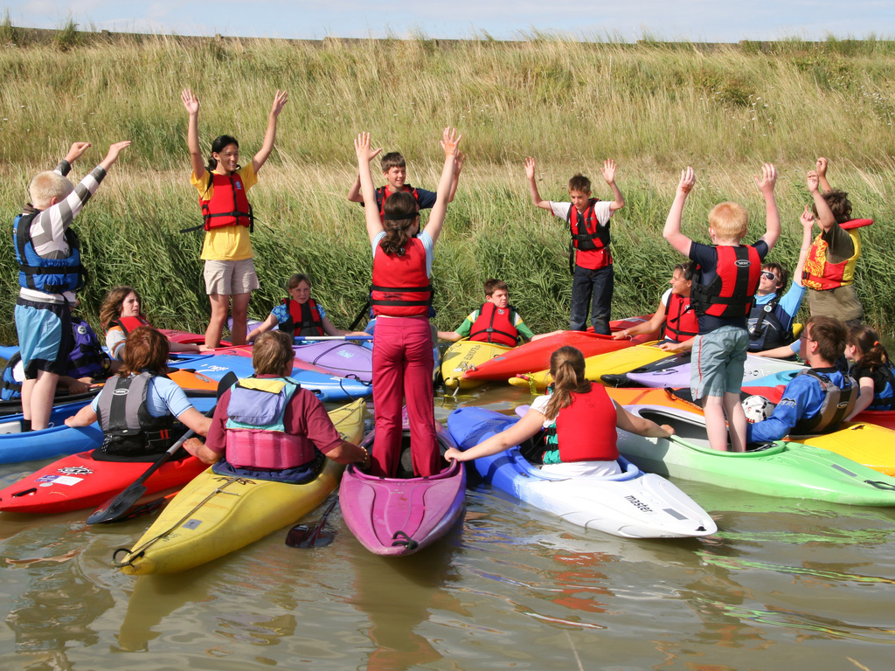



Staffordshire County Scouts

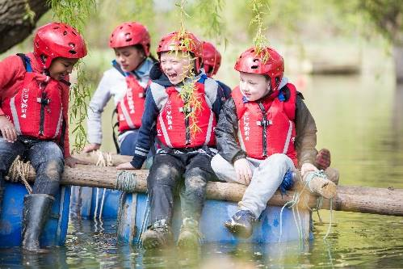
About Us

Staffordshire Scout County is a thriving County with 12 Districts and over 7,900 young members and 2600 adults.

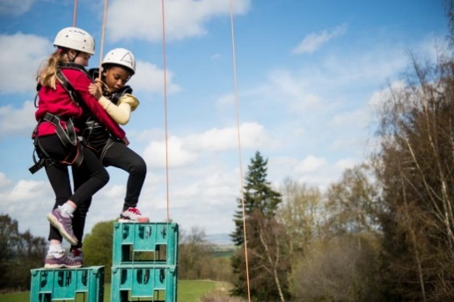
Supporting Adventure

Staffordshire County are responsible for supporting the delivery of active and adventurous programmes for all sections.

In all sections the focus is on the delivery of a balanced yet exciting programme with a focus on developing skills for life through outdoor activities and adventure.

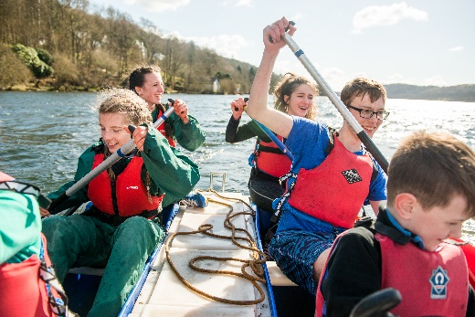
Youth Focus

Through our Youth Shaped initiative, we reflect the fact that Scouting is a youth Organisation led by young people and supported by adults. Young people are at the heart of our decision making with respect to programme, events and competitions and influence our development strategies, local objectives, priorities, and governance.

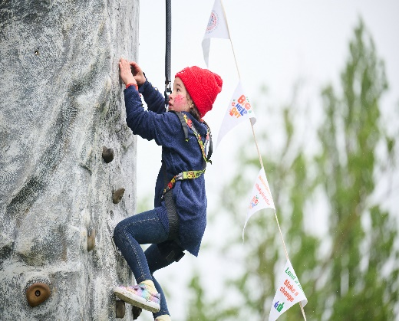
Development

Scouting is a growing movement and Staffordshire County has potential for good growth of both youth Members and Adult volunteers. Supporting growth and development is important to ensure that we can accommodate the growing number of young people who wish to join the world’s largest and most successful youth movement. This means recruiting more adults and opening new provision to meet demand.

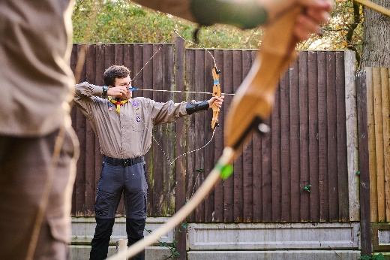
Find out more

To find out more about us please visit our website at

www.staffordshirescouts.org.uk

Thank you for considering the role of County Programme Team – Scouts/Explorers or nominating someone you think would be good for the role, it will make a huge difference to Scouting in Staffordshire.
ROLE DESCRIPTION
This vacancy is for County Programme Team – Scouts/Explorers. At the 2023 membership census we had over 7900 youth members between the ages of 4 and 25 involved in our Squirrel, Beaver, Cub, Scout, Explorer, Network and Young Leader sections. We have over 2600 adult volunteers, who undertake roles including working directly with young people, adults who manage and support other adults, adults who are experts in programme and activity areas and adults who support elements of the programme along with adults who manage and support the governance of districts and groups.
County Programme Team
The team is made up of:
- County Programme Team – Squirrels
- County Programme Team – Cubs
- County Programme Team – Beavers
- County Programme Team – Scouts
- County Programme Team – Explorers
- County Programme Team – Activities Team Lead and Sub-teams
- County Programme Team – Top Awards
- County Programme Team – Network
- County Programme Team – SAS Skills
- County Programme Team – SAS DofE Expedition Assessors
Purpose
This role supports District Programme Team Leads for Scouts or Explorer sections and it aims to bring a balanced programme to these sections on a County wide basis. The role is line managed by the County Team Lead – Programme.
This role can be split into two with an emphasis on either the Scout or Explorer section and tasks can be shared by a team.
Responsibilities
- Support the County in embedding a balanced programme in Districts/Groups
- Promote Top Awards
- Assist with organising and running events to support the programme
- Promote moving-on to next sections
- Assist District Programme Leads – Scouts/Explorers in the encouragement and support of section leaders.

Not sure you're right for the role? Then have an informal chat with us first and find out a bit more. If you need any further information on these roles, please contact Phil Hassall Phil.Hassall@staffordshirescouts.org.uk
Expression of Interest for County Programme Team – Scouts/Explorers
If you are interested in the role, please complete the expression of interest form below, it should then be sent via email to the County Office.
E-mail: admin@staffordshirescouts.org.uk Closing date 30th November 2023

Name
Address
Telephone number
E-mail address
Scout Association membership number
(if appropriate and known)
Please explain why you feel you are suitable for this role.
This could include any professional and voluntary experience, hobbies, skills or interests; from inside or outside of Scouting.

Please outline why you are interested in this role.
Any other comments

Thank you for taking the time to complete this form, someone will be in contact shortly.

