Staffordshire County
Team Safety Advisor
Vacancy Pack and Role Description

Staffordshire

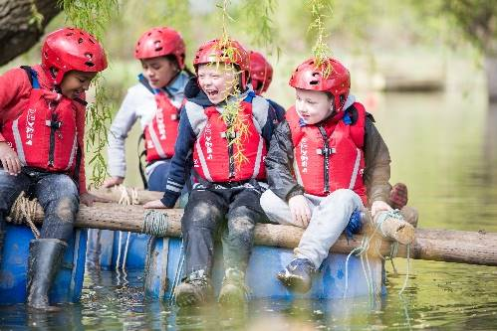
About Us

Staffordshire Scout County has over 7900 young members and 2600 adult leaders. We operate in supporting the delivery of scouting across 12 Districts.

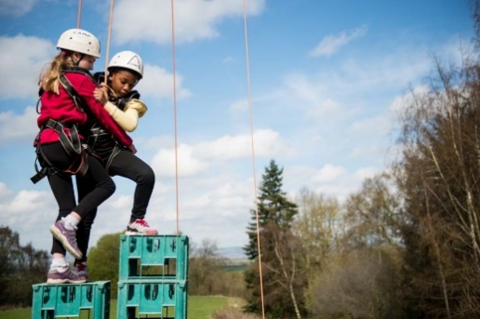
Supporting Adventure

Staffordshire are responsible for supporting the delivery of active and adventurous programmes for all sections.

The focus is on the delivery of a balanced yet exciting programme with a focus on developing skills for life through outdoor activities and adventure.

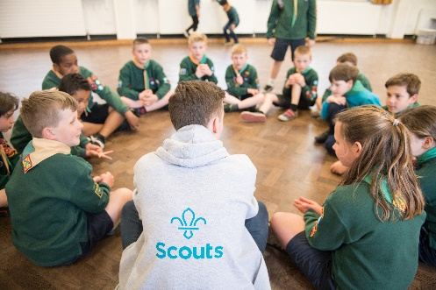
Youth Focus

Through our Youth Shaped initiative, we reflect the fact that Scouting is a youth organisation led by young people and supported by adults. Young people are at the heart of our decision making with respect to programme, events and competitions and influence our development strategies, local objectives, priorities, and governance.

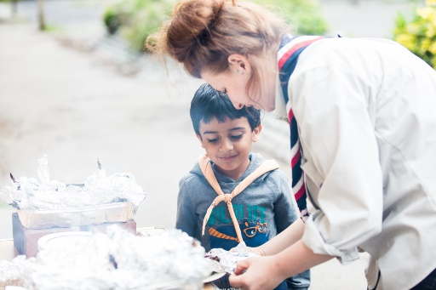
Development

Scouting is a growing movement and has potential for good growth of both youth Members and Adult volunteers. Supporting growth and development is important to ensure that we can accommodate the growing number of young people who wish to join the world’s largest and most successful youth movement. This means recruiting more adults and opening new provision to meet demand.

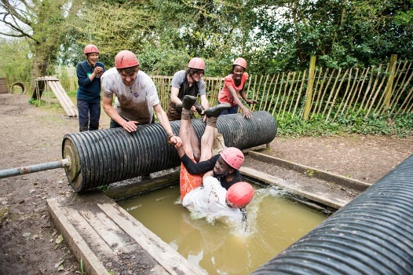
Find out more

To find out more about us please visit our website at

www.staffordshirescouts.org.uk

Thank you for considering the role of Safety Advisor or nominating someone you think would be good for the role, it will make a huge difference to Staffordshire County.

ROLE
DESCRIPTION
This vacancy is for Staffordshire County Team Safety Advisor. At the 2023 membership census we had over 7900 youth members between the ages of 4 and 25 involved in our Squirrels, Beaver, Cub, Scout, Explorer, Network and Young Leader sections. We have over 2600 adult volunteers, who undertake roles including working directly with young people, adults who manage and support other adults, adults who are experts in programme and activity areas and adults who support elements of the programme
.A full and comprehensive induction, as well as ongoing support will be provided to the successful candidate,
This role can be shared by a team of volunteers.
Title: County Team Safety Advisor

Outline: To advise the County Team and Trustees on the implementation of the Scout’s Safety Policy within the County and to promote the Scout’s Safety Policy within the County. To support District Lead Volunteers in operating the policy.

Responsible to: County Team Lead - Support

Main Contacts: County Chair, County Trustee Board, County Team members, District Lead Volunteers, HQ Safety in Scouting Co-ordinator.

Appointment Requirements:

Must successfully complete the appointment process (including acceptable personal enquiries and acceptance of The Scouts policies).

- Complete the Getting Started Training within the first 5 months in this role and keep mandatory ongoing learning current during the time in this role.
- This role does not require qualifications or external experience in safety; however, this may be beneficial. Experience or knowledge of safety within in the Scouts is desirable. Those without recent experience will be expected to undergo relevant learning”.
- This role is not involved in the delivery of Scouts training but may be involved in the delivery of workshops to support local understanding.
- Following the appointment this role will attend a national induction for the role and will continue with regular engagement with the Safe Scouting Department.

Main Tasks
- Provide support across the County on matters of safety i.e., providing advice to Trustee Boards, Lead Volunteers, supporting with local understanding of risk assessment.

- Ensuring members within the County stay up to date on safety advice, guidance and rules to promote a culture of Safe Scouting across the local area. This could be through attendance at meetings or by providing updates such as webinars or in local newsletters.

- Providing a level of assurance for the County Trustee Board. This can include but is not limited to reviewing risk assessments, auditing safety procedures for premises (such as local Campsites) and other tasks as requested by the County Lead Volunteer or County Trustee Board.

- Collaborate with all adults to ensure that The Scouts safety policy is understood and implemented at all levels.

- Provide information and support to event organisers on how to ensure events are delivered safely and in line with Scouts policies.

- Support the County Lead Volunteer, District Lead Volunteers and Group Lead Volunteers to use tools and checkers (such as the ‘Keeping Scouting Good’ and ‘Safe Scouting premises checker’) and be available to offer help and support in implementing resulting actions.

- Keep up to date with national Scouts developments relating to safety, using the information available (including management information and data, local and national learnings) to support and develop a culture of Safe Scouting within the County/Area/Region (Scotland).

- Supporting local learning reviews, ensuring that lessons are learnt from incidents and near misses within the County (including those at Group and District levels). Review and update the County Safety Policy; with the County Management Team agree a process for implementation across all County Teams

Other Tasks Agreed with the County Team
The immediate focus of the role is to support the County Trustee Board in ensuring that the County fulfils its responsibilities in respect of the Scout’s Safety Policy for all County led activities. Key actions will include:

Review and update reporting arrangements to County Trustee Board for County areas of responsibility; with the County Management Team agree a process for implementation across all County Teams

Provide practical support and assistance to County teams (including Activities and Programme teams, teams running International and big County events, Training team and Appointments Advisory Committee) in managing safety issues relevant to their responsibilities.

Development of resources on the County website for members of the County team. This will also be accessible to the wider scouting membership in Staffordshire and be one of the main ways support is provided to Districts.

Establish a culture of safety within Staffordshire Scouting by supporting and working with all districts.

Nomination form for County Team Safety Advisor
If you think you know just the right person for this role, or are interested in the role yourself, please complete the nomination form below, it should then be sent to Helen Wilcox via:
- E-mail admin@staffordshirescouts.org.uk

Closing date 30th November 2023

Name of person you are nominating
Their address
Their telephone number
Their e-mail address
Their Scout Association membership number
(if appropriate and known)
Please explain why this person is suitable for this role, including relevant professional and voluntary experience from inside or outside Scouting (refer to role description).
Please describe the relevant skills that this person has for the role (refer to role description).
Please outline why you felt motivated to complete the nomination/self-nomination.
Your name:
Your telephone number:
Your e-mail address:

