County Support Team – Grants Lead

Vacancy Pack and Role Description

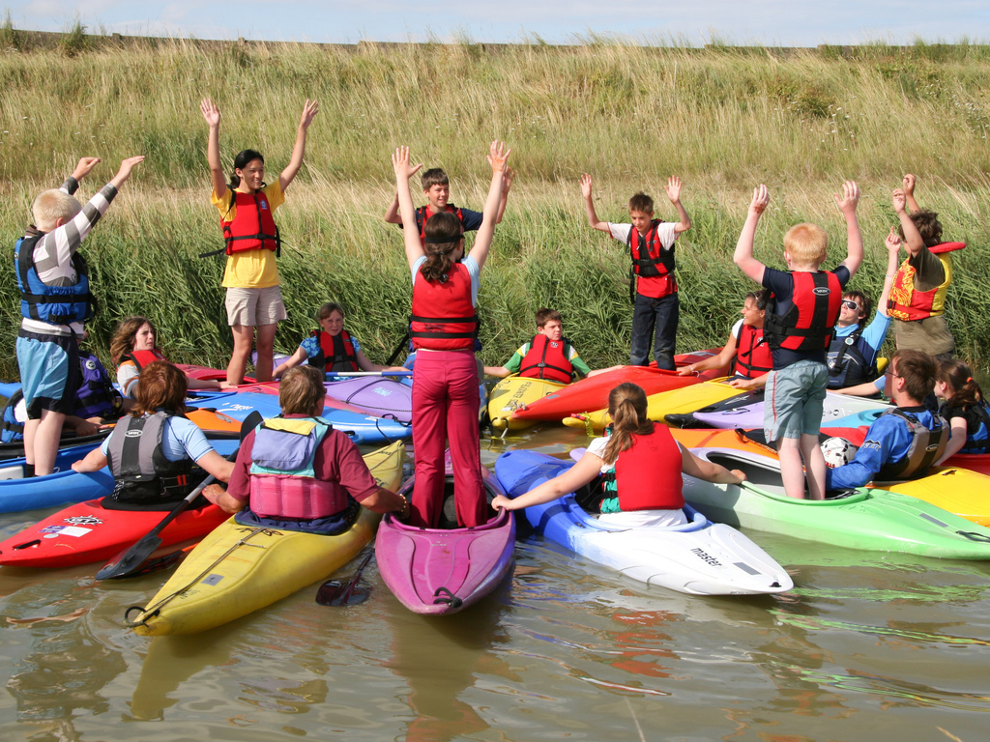

Staffordshire County Scouts

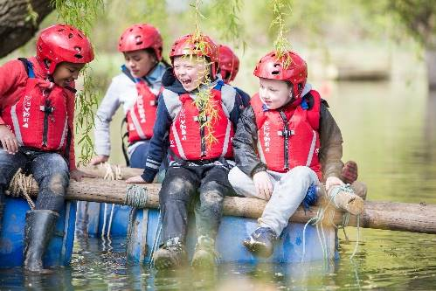
About Us

Staffordshire Scout County is a thriving County with 12 Districts and over 8,000 young members and nearly 3,000 adults.

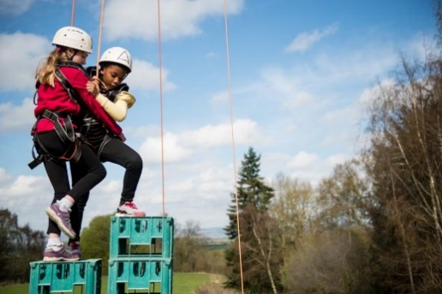
Supporting Adventure

Staffordshire County are responsible for supporting the delivery of active and adventurous programmes for all sections.

In all sections the focus is on the delivery of a balanced yet exciting programme with a focus on developing skills for life through outdoor activities and adventure.

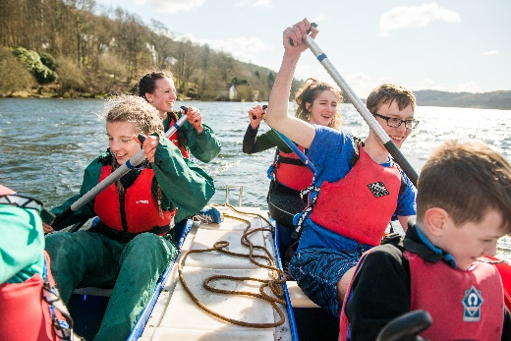
Youth Focus

Through our Youth Shaped initiative, we reflect the fact that Scouting is a youth Organisation led by young people and supported by adults. Young people are at the heart of our decision making with respect to programme, events and competitions and influence our development strategies, local objectives, priorities, and governance.

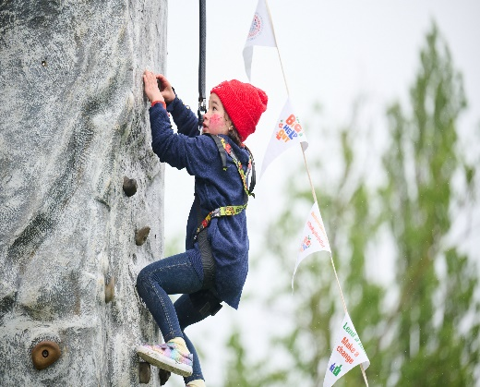
Development

Scouting is a growing movement and Staffordshire County has potential for good growth of both youth Members and Adult volunteers. Supporting growth and development is important to ensure that we can accommodate the growing number of young people who wish to join the world’s largest and most successful youth movement. This means recruiting more adults and opening new provision to meet demand.

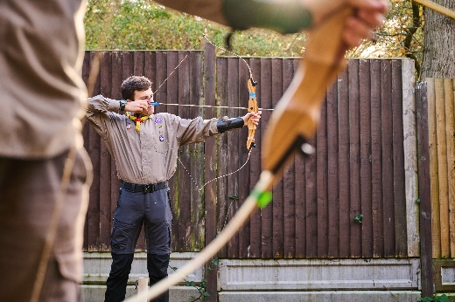
Find out more

To find out more about us please visit our website at

www.staffordshirescouts.org.uk

Thank you for considering the role of Grants lead or nominating someone you think would be good for the role, it will make a huge difference to Scouting in Staffordshire.
ROLE DESCRIPTION
This vacancy is for County Support Team – Grants Lead. At the 2024 membership census we had over 8,000 youth members between the ages of 4 and 25 involved in our Squirrel, Beaver, Cub, Scout, Explorer, Network and Young Leader sections. We have nearly 3,000 adult volunteers, who undertake roles including working directly with young people, adults who manage and support other adults, adults who are experts in programme and activity areas and adults who support elements of the programme along with adults who manage and support the governance of districts and groups.
County Support Team
The team is made up of:
- County Support Team – Media
- County Support Team – Website
- County Support Team – Data Support
- County Support Team – Development
- County Support Team – Young Leaders
Purpose
To play a crucial part in supporting County Scouting through successful grant applications.
This role can be shared by a team.
Responsibilities
- Grant research – find funders that align to our mission and values
- Grant applications - construct proposals that will convince funders that we are worthy of their support
- Collaborate with other members of the County Team and Trustee Board to understand need and gain information
- Grant reporting – preparing timely reports on the impact we make with funders money

Not sure you're right for the role? Then have an informal chat with us first and find out a bit more. If you need any further information on these roles, please contact Esther Bromley esther.bromley@staffordshirescouts.org.uk
Expression of Interest for County Support Team – Grants Lead
If you are interested in the role, please complete the expression of interest form below, it should then be sent via email to the County Office.
E-mail: admin@staffordshirescouts.org.uk Closing date 14th April 2024

Name
Address
Telephone number
E-mail address
Scout Association membership number
(if appropriate and known)
Please explain why you feel you are suitable for this role.
This could include any professional and voluntary experience, hobbies, skills or interests; from inside or outside of Scouting.

Please outline why you are interested in this role.
Any other comments

Thank you for taking the time to complete this form, someone will be in contact shortly.

