County Team Leader – Volunteer Development
Staffordshire County Scouts
Vacancy Pack and Role Description

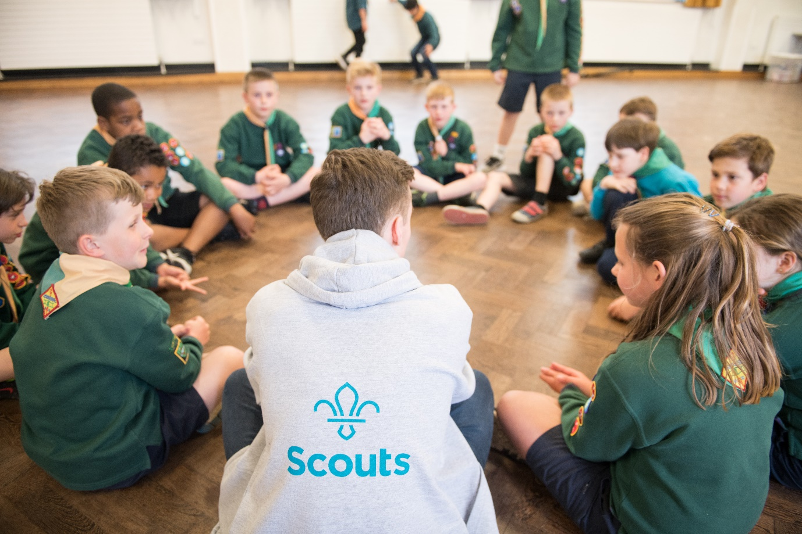

Staffordshire County

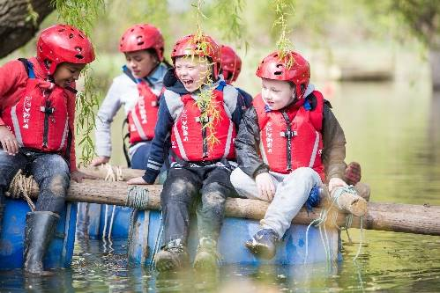
About Us

Staffordshire Scout County is a thriving County with 12 Districts and over 8,000 young members and nearly 3,000 adults.

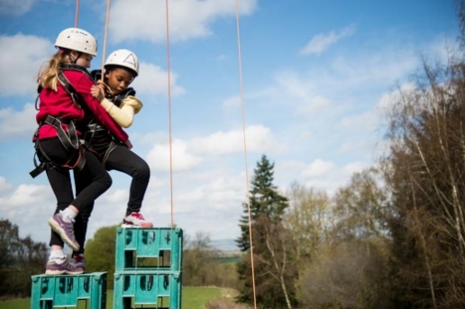
Supporting Adventure

Staffordshire County are responsible for supporting the delivery of active and adventurous programmes for all sections.

In all sections the focus is on the delivery of a balanced yet exciting programme with a focus on developing skills for life through outdoor activities and adventure.

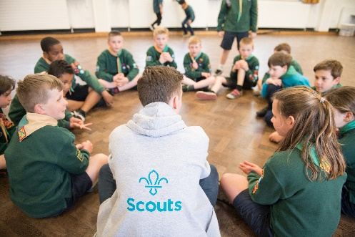
Youth Focus

Through our Youth Shaped initiative, we reflect the fact that Scouting is a youth Organisation led by young people and supported by adults. Young people are at the heart of our decision making with respect to programme, events and competitions and influence our development strategies, local objectives, priorities, and governance.

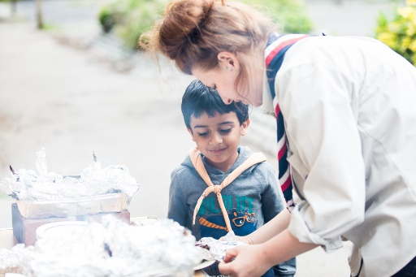
Development

Scouting is a growing movement and Staffordshire County has potential for good growth of both youth Members and Adult volunteers. Supporting growth and development is important to ensure that we can accommodate the growing number of young people who wish to join the world’s largest and most successful youth movement. This means recruiting more adults and opening new provision to meet demand.

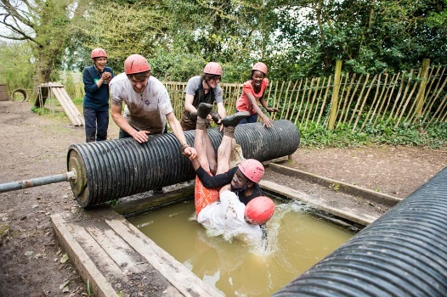
Find out more

To find out more about us please visit our website at

www.staffordshirescouts.org.uk Thank you for considering the role of County Team Lead - Volunteer Development or nominating someone you think would be good for the role, it will make a huge difference to Scouting in Staffordshire.

ROLE
DESCRIPTION
This vacancy is for the County Team Lead – Volunteer Development of Staffordshire County Scouts, At the 2024 membership census we had over 8,000 youth members between the ages of 4 and 25 involved in our Squirrel, Beaver, Cub, Scout, Explorer, Network and Young Leader sections. We have nearly 3,000 adult volunteers, who undertake roles including working directly with young people, adults who manage and support other adults, adults who are experts in programme and activity areas and adults who support elements of the programme along with adults who manage and support the governance of districts and groups.
Purpose
The County Volunteering Development Team makes sure all volunteers in County teams have a fantastic volunteering experience. By doing so, they’ll make it easy for people to join and learn new skills.

Who's in the team
- Volunteering Development Team Leader
- County Training Manager
- Events Team
- Communications and Marketing Team
- Appointments Team
- Awards Team
- Inclusion Team
- Growth Team

Tasks for the whole team
Make sure all District Teams follow and reflect on our volunteering culture

Allocated tasks
Attract and welcome new volunteers to County teams
- Use Scouts branded resources to attract new volunteers.
- Reply quickly and positively to possible new volunteers.
- Make sure new volunteers are welcomed easily and smoothly.
- Introduce new volunteers to District Lead Volunteers and members of county teams.
Make sure volunteers are well-supported
- Help and encourage County Team Leaders to regularly check in with their Team Members to make sure they’re enjoying volunteering.
- Make sure all County Teams (including District Lead Volunteers) follow our approach to safe volunteer recruitment, appointment, reviews, and processes for leaving Scouts.
Help volunteers in County teams with learning
- Make sure volunteers across the County can access relevant Managers and Supporters training
- Help volunteers find and engage in opportunities for learning and development.
- Coordinate Scouts learning that needs to be delivered by an accredited trainer
- Use the learning delivery materials developed by Scouts (e.g. training sessions, workshops, activities, etc.), and make changes (when necessary) so activities are accessible for everyone.
- Help volunteers connect across the County and beyond to learn, share best practices and overcome shared challenges.
- Set up helpful learning opportunities with external organisations, if it’s relevant and helpful for volunteers.
- Make sure volunteers can be recognised for prior learning and experience, and have it credited in their records.
- Learn from people in other volunteering development teams
Recognise volunteers
- Recognise and show appreciation for volunteers’ brilliant work, formally and informally.
Support growth across the county
- encourage growth in YP and volunteers across the district
- Support districts and groups with their growth plans in the community
- work with the regional growth and communities' team to maximise available resources
- develop and monitor the county growth plan by working with districts

The Scouts is currently going through a transformation change and therefore the details relating to the role may be subject to change sometime in the near future.
If you need any further information on the role please contact the County Commissioner, Richard Williams – richard.williams@staffordshirescouts.org.uk

Nomination form for County Team Lead – Volunteer Development
If you think you know just the right person for this role, or are interested in the role yourself, please complete the nomination form below, it should then be sent to the County Office
- E-mail admin@staffordshirescouts.org.uk

Closing date 31st March 2024

Name of person you are nominating or your name
Their/your address
Their/you telephone number
Their/your e-mail address
Their/your Scout Association membership number
(if appropriate and known)
Please explain why this person or yourself is suitable for this role, including relevant professional and voluntary experience from inside or outside Scouting (refer to role description).
Please describe the relevant skills that this person/you have for the role (refer to role description).
Please outline why you felt motivated to complete the nomination/self-nomination.
Your name:
Your telephone number:
Your e-mail address:

