District Lead Volunteer
Burton-upon-Trent

Vacancy Pack and Role Description

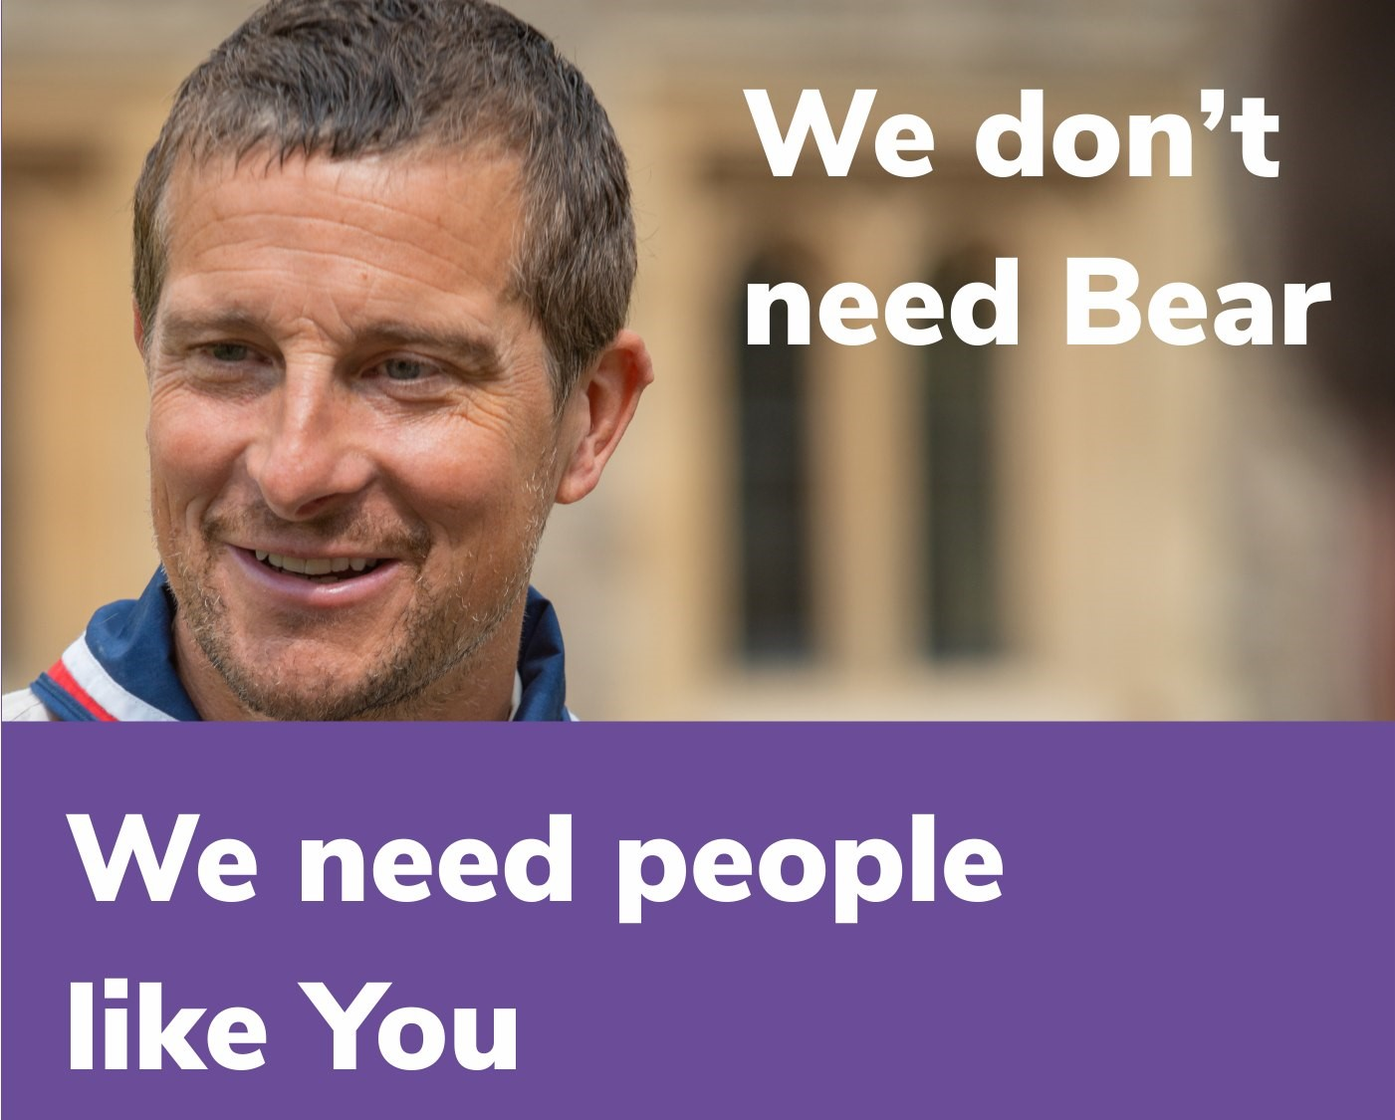

Burton-upon-Trent District Scouts

About Us

Burton-upon-Trent is a thriving District with 10 Groups, 855 young members and 215 adults.

Supporting Adventure

Burton-upon-Trent District Scouts are responsible for

supporting the delivery of active and adventurous programmes for all sections. In all sections the focus is on the delivery of a balanced yet exciting programme with a focus on developing skills for life through outdoor activities and adventure.

Youth Focus

Through our Youth Shaped initiative, we reflect the fact that Scouting is a youth Organisation led by young people and supported by adults. Young people are at the heart of our decision making with respect to programme, events and competitions and influence our development strategies, local

objectives, priorities, and governance.

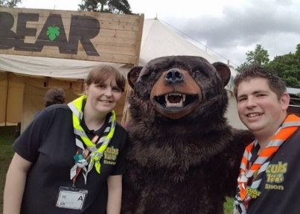
Development

Scouting is a growing movement and Burton-upon-Trent District has potential for good growth of both youth Members and Adult volunteers. Supporting growth and development is important to ensure that we can accommodate the growing number of young people who wish to join the world’s largest and most successful youth movement. This means recruiting more adults and opening new provision to meet demand.

Find out more

To find out more about us please visit our website at

www.burtonscouts.org.uk

Thank you for considering the role of District Lead Volunteer or nominating someone you think would be good for the role, it will make a huge difference to Scouting in Burton-upon-Trent.
ROLE DESCRIPTION
This vacancy is for a District Lead Volunteer. At the 2024 membership census we had 855 youth members between the ages of 4 and 25 involved in our Squirrel, Beaver, Cub, Scout, Explorer, Network and Young Leader sections. We have 215 adult volunteers, who undertake roles including working directly with young people, adults who manage and support other adults, adults who are experts in programme and activity areas and adults who support elements of the programme along with adults who manage and support the governance of districts and groups.
Purpose
The District Lead Volunteer is a key role which provides leadership and management to all adult and youth members of the District.
The role also requires the right individual to:
- Provide strategic leadership to Scouting in the District
- Ensure that good quality Scouting is delivered to young people
- Develop Scouting in the District
- Promote and maintain the policies of The Scout Association
- Positively manage and support adults, defining roles and responsibilities
Responsible to:
County Lead Volunteer
Responsible for:
Group Lead Volunteers, District Team Leads, District Nights Away Advisors
Main contacts:
District Chairperson, Group Lead Volunteers, District Team Leads, County Lead Volunteers, County Team Leaders, District Trustee Board, England Headquarters Staffs and Volunteers, other statutory and voluntary youth organisations, local authorities
Appointment requirements:
- Understand and accept The Scout Association’s policies
- Satisfactory DBS clearance
- Completion of appropriate learning
- Eligible for Charity Trustee status
Main Responsibilities

- Ensure that the District has an adequate number of ‘fit and proper’ adults working effectively together to meet the Scouting needs of the District
- Ensure that all adults are adequately supported including induction, training, review and development
- Produce a District Development Plan providing a vision and strategy that ensures the Scouting needs within the District are met
- Resolve problems or disputes that occur within the District
- Appoint a District Chairperson
- Manage a team of adults including regular meetings with District Team and Trustee Board
- Ensure the presence of an effective 14-25 provision within the District
Core Tasks
Manage a team of District Team Leaders and Advisers

- Ensure that certificates of appointment are presented to adults in the District
- Ensure that adequate procedures are in place and followed and ensure that all activities and meetings in the District are safe and follow the rules of The Scout Association
- Recommend and present awards for adult members of the District
- Ensure that the District is represented at Group Annual General Meetings
- Appoint Lead Volunteers in key areas such as:

- Programme
- Development
- Support
- Governance
- Other areas as appropriate

Work in partnership with County and District Teams
- Ensure effective teams are appointed to support Groups, Explorer Scout Units and District Network
- To annually review progress, standards and effectiveness of development plans, and redefine future targets and tasks for development of Scouting in the District
- Arrange regular meeting with the District Team to discuss and resolve current issues
- Arrange regular visits to Groups to listen to their views, understand and help resolve issues and note and share good practise
- Support the District Team and Group Lead Volunteers in their personal learning and development
- Represent the District at meetings with the County Lead Volunteer and other District Lead Volunteers
- Represent the County Lead Volunteer within the District
- Communicate views arising from meetings with the District Team
- Inform the County Lead Volunteer of District needs and issues

Work in partnership with the District Trustee Board
- Annually nominate the District Chairperson
- Keep the Trustee Board advised of financial and other resource requirements of delivering Scouting safely
- Annually appoint members of the District Scout Council to service on the District Trustee Board
- Produce an annual summary/review of Scouting in the District for the District Scout Council and County Lead Volunteer
- Develop and maintain good working relationships, seeking contacts internal and external to Scouting within the local community

Person Specification

Essential | Desirable
The ability to communicate (verbal and non-verbal) with a variety of audiences | Scouting experience at a level which supports the tasks
The ability to lead and manage a team | Able and willing to travel to all groups within the District
Able to deliver as promised | Be reasonably local to Burton-upon-Trent
Is biased to action | Manage home, social, work and scouting in a balanced lifestyle
Able to show initiative
Ability to motivate and enthuse others
Effective time management

Not sure you're right for the role? Then have an informal chat with us first and find out a bit more. If you need any further information on these roles, please contact Esther Bromley esther.bromley@staffordshirescouts.org.uk

Expression of Interest – District Lead Volunteer, Burton-upon-Trent
If you are interested in the role, please complete the expression of interest form below, it should then be sent via email to esther.bromley@staffordshirescouts.org.uk
Closing date 30th April 2024

Name of nominee or applicant
Address
Telephone number
E-mail address
Scout Association membership number
(if appropriate and known)
Please explain why you/this person is suitable for this role.
This could include any professional and voluntary experience, hobbies, skills or interests; from inside or outside of Scouting.

Please outline why you felt motivated to complete the nomination/application
Please describe the relevant skills you/this person has for the role

Any other comments

Please complete this section if you are nominating someone else for the role
Nominated by
Address
Telephone number
E-mail address
Scout Association membership number
(if applicable)

Thank you for taking the time to complete this form, someone will be in contact shortly.

